Stockholm 2017-06-30
Dear Mr Catalin Marinescu,

In response to your letter of 1st of June 2017, ref CL-17/25, Ericsson hereby provides a response to your kind Invitation to provide inputs to the “Invitation to provide inputs to the 1st public consultation on the ITU strategy for 2020-2023”
Response to Public Consultation Questions by the CWG-SFP:
- What should be the key strategic priorities for ITU for the 2020-2023 period, taking into account the UN 2030 Agenda for Sustainable Development and the Sustainable Development Goals?

From the latest Mobility Report released by Ericsson on June 13th https://www.ericsson.com/en/mobility-report it can be noted that by 2022, 600 Million people will despite the success IMT 2000 and following IMT technologies, will still be outside of the reach of Internet. Some of the challenges remaining to connect and create an Internet for all lies in areas such as Literacy, Affordability, small language domains that cannot be solved by Technology.
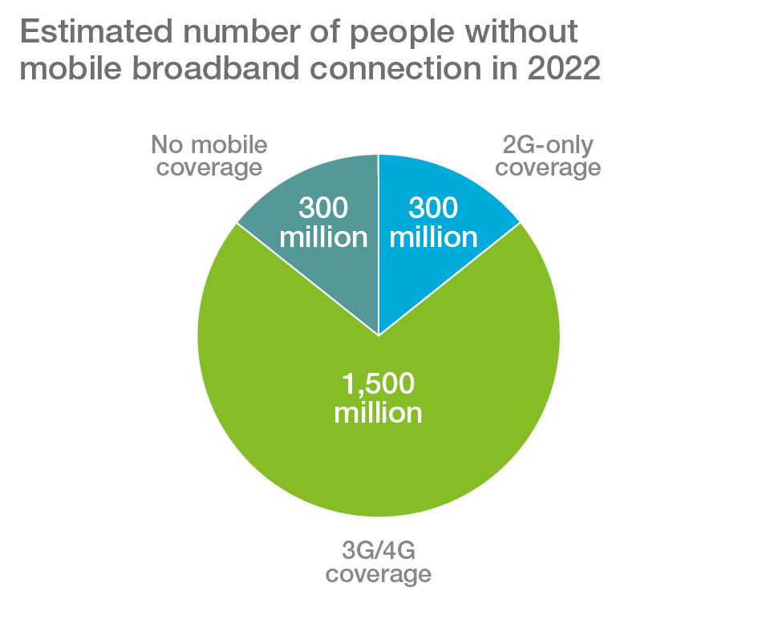
ITU has significant opportunities as we are moving into IMT 2020 to address Government and other Nations state bodies to promote programs to support deeper deployment of networks as well as focused programs to increase literacy and poverty eradication, well supporting the UN Sustainability Development Goals.
- What are the key technological trends ITU should consider while planning its strategy?
Even though specifications for IMT-2020 will be approved by 2020 and that 5G be commercially deployed it is important that ITU continue to embrace and publish standards for global use. For the telecom industry and the benefit of other industries it is of importance that global standards are developed as well as finding global spectrum allocations for wireless use. To maintain and introduce following IMT standards would be a main strategic topic.
What do you consider to be the top three challenges for the ITU and the top three achievements you would like to see the ITU accomplish in the 2020-2023 timeframe?
a) Produce recommendations for global standards.
b) Identify spectrum for global usage
c) Remove non-technical barriers that hinder access to internet

Regards Jan Färjh
VP, Head of Standardization and Industry Initiatives, Ericsson AB

